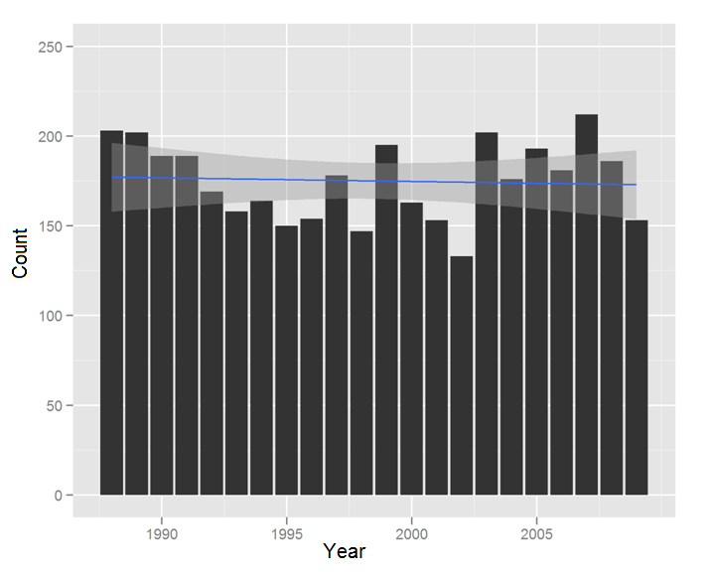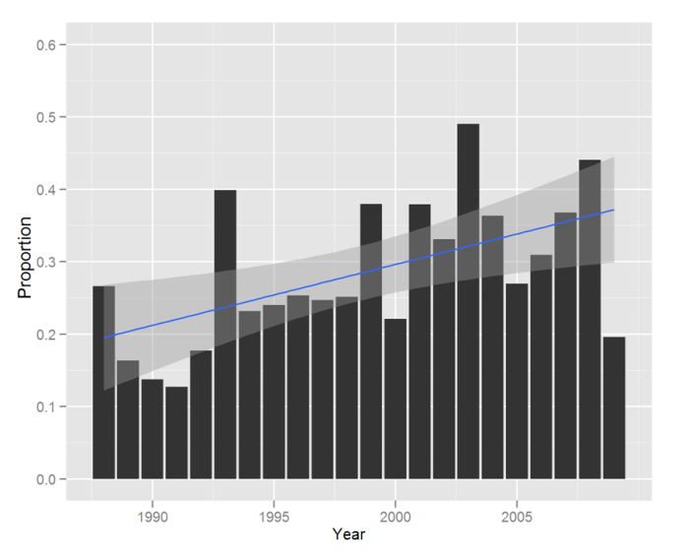

**Figure 1: The number of sinonasal cancer surgeries has not changed significantly over the last twenty years, however an increasing proportion of these surgeries are performed at high volume centers. A: Total number of sinonasal cancer surgeries per year. B: Proportion of sinonasal cancer surgeries performed at high volume centers per year.**

Supplemental Figures

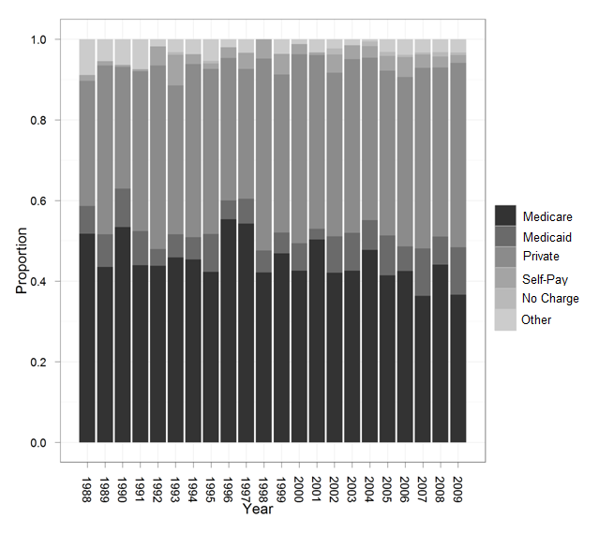

**Figure A: Sinonasal surgery patient’s insurance status has not significantly changed over time.**

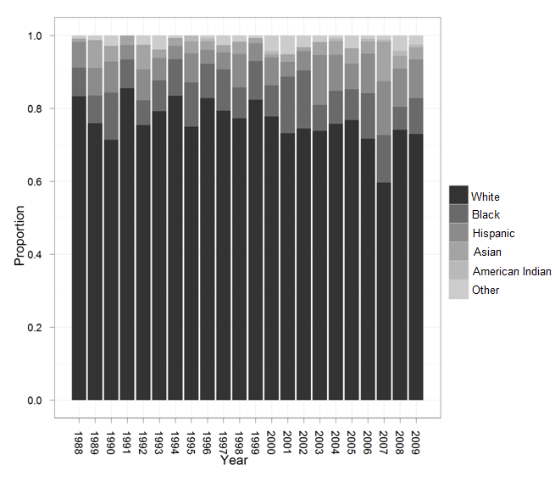

**Figure B: Sinonasal surgery patient’s race has not significantly changed over time.**

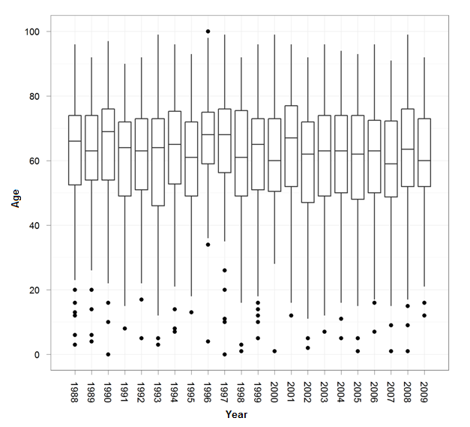

**Figure C: Sinonasal surgery patient’s age distribution has not significantly changed over time.**